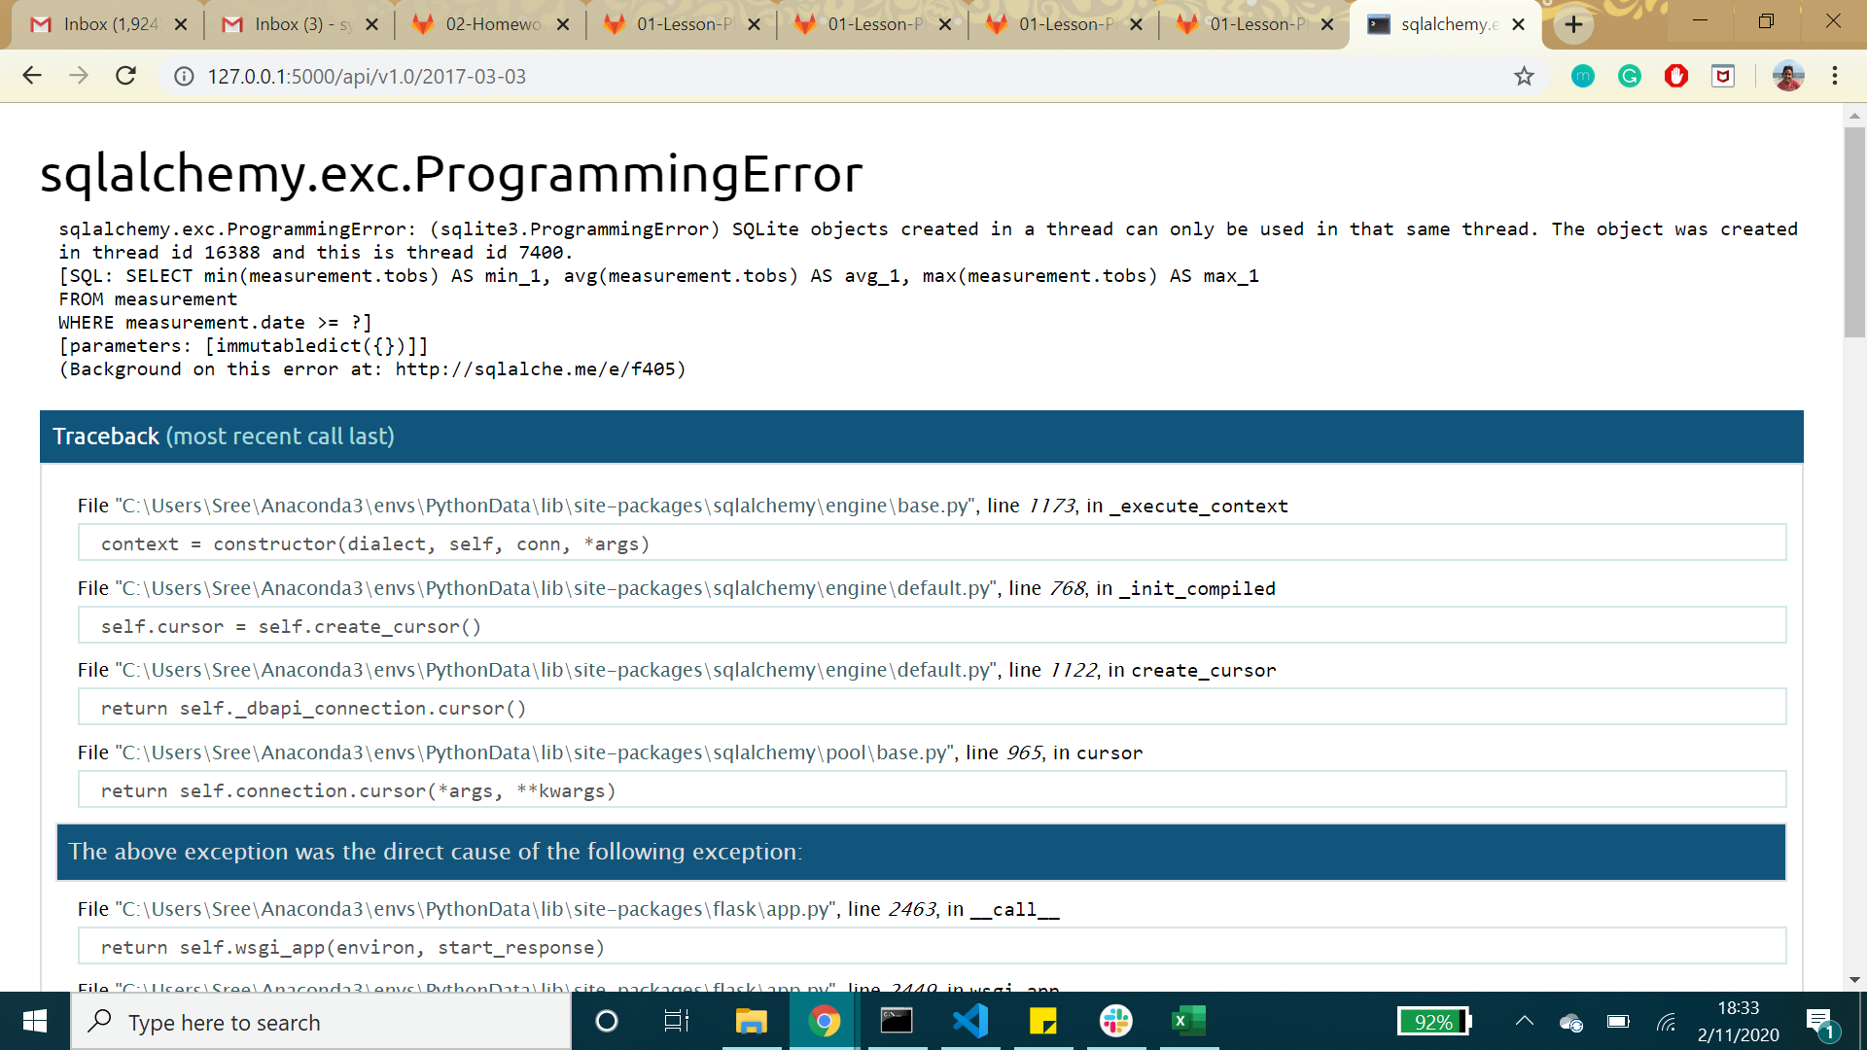

While working with Flask APIs and my app.py file, I received this error message at the end. This involved the link for the start and end vacation dates. When I ran it the first time, it perfectly displayed the minimum, maximum, and average temperatures for any given date. However, when I input another date or date range, I often got this error. For the purposes of this homework assignment, I thought it would be appropriate to mention this as an additional note for my home. For the future, I intend to work on this assignment for my own personal development and I would like to understand this type of error and how to debug it.